Topic 7 Gravitational Field

Learning Outcomes

- Show an understanding of the concept of a gravitational field as an example of field of force and define gravitational field strength as force per unit mass.
- Recall and use Newton’s law of gravitation in the form 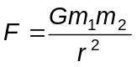.
- Derive, from Newton’s law of gravitation and the definition of gravitational field strength, the equation 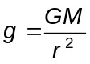 for the gravitational field strength of a point mass.
- Recall and apply the equation for the gravitational field strength of a point mass to new situations or to solve related problems.
- Show an appreciation that on the surface of the Earth g is approximately constant and equal to the acceleration of free fall.
- Define potential at a point as the work done in bringing unit mass from infinity to the point.
- Solve problems using the equation 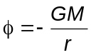 for the potential in the field of a point mass.
- Recognise the analogy between certain qualitative and quantitative aspects of gravitational and electric fields (to be done together with the topic electric fields)
- Analyse circular orbits in inverse square law fields by relating the gravitational force to the centripetal acceleration it causes.
- Show an understanding of geostationary orbits and their application.

7.1 Introduction

In the topics of Dynamics, Forces, etc, we have been dealing with weights of different objects. Weight is a name given to the force acting on the object by gravity. In other words, weight is a gravitational force.
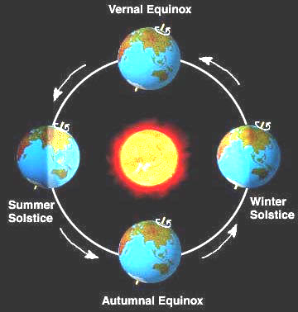
Gravitational force is a force that is evident in our everyday lives and plays a crucial role in many processes on Earth. For instance, the ocean tides are caused by the gravitational attraction of both the Moon and Sun on the earth’s oceans. The falling of objects when released is also caused by the gravitational pull of the Earth on all objects. In terms of planetary motion, gravitational force is responsible for keeping the Earth in its orbit around the Sun, which in turns gives rise to four seasons in some countries.

7.2 Newton’s Law of Gravitation
LO (b)
Gravitation is a natural phenomenon by which physical bodies attract each other due to their masses. This force occurs whenever masses are present and the two bodies need not to be in contact with each other. It is however the weakest of the fundamental forces of nature.

In 1687, Sir Isaac Newton concluded that this non-contact gravitational force must be as responsible for the falling of the apple from a tree as it is the cause for the rotation of the moon about the earth. Hence he published the Newton’s law of gravitation which states that:
“The mutual force of attraction between any two point masses is
directly proportional to the product of their masses and
inversely proportional to the square of the separation between their centres.”

“Every particle in the Universe attracts every other particle with a force that is directly proportional to the product of their masses and inversely proportional to the square of the distance between them.”
F
M
r
m
F

This means that if there are two point masses M and m and they are separated by distance r, the magnitude of the gravitational force attracting them to each other is
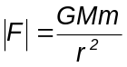

where G, the constant of universal gravitation, is 6.67 x 10⁻¹¹ N m² kg⁻² (will be given in data & formulae list during tests and examinations).

Note:
- r is taken to be the centre−to−centre distance (i.e. centre of particle to centre of particle). Do not take r to be the radius of orbit!
2. This formula is an example of the inverse square law.

Inquiry:
1) What can you conclude about the two forces in the above diagram?
The two forces in the diagram are action-reaction pair because each force is acting on the particle by the other particle.

2) In that case, when Earth pulls you down, why did you not pull Earth up?
You did! But the mass of Earth is relatively much bigger than my mass and
hence its acceleration is relative much smaller.
Example 1
(a) Calculate the gravitational force exerted between the Earth and its Moon, given mass of the Earth, M_{E} = 6.0 × 10²⁴ kg; mass of the Moon, M_{M} = 7.4 × 10²² kg; distance between the centres of the Earth and Moon, D = 3.8 × 10⁸ m)
Gravitational force: 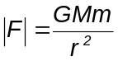= 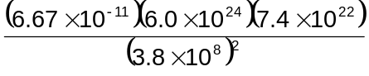 = 2.05 x 10²⁰ N

(b) Estimate the gravitational force exerted between you and your nearest neighbour in this lecture theatre.
Assume that both masses are 50 kg each and the distance between the centres of gravity of the two persons is 0.50 m.
Magnitude of the force = 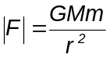= 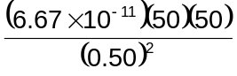 = 6.67 x 10⁻⁷ N
(Note: This force is smaller than 0.01% of the weight of an A4-size paper!)

The gravitational force exerted on each other is the same and attractive in nature.
Assume that both masses are 50 kg each and the distance between the centre of gravity of the two persons are 0.50 m apart.
Magnitude of the force = GMm/r² = (6.67 x 10⁻¹¹)(50)²/(0.50)² = 6.67 x 10⁻⁷ N
-
Example 2 (N84/P2/Q7) Binary Stars
Two stars of equal mass M move with constant speed v in a circular orbit of radius R about their common centre of mass O. What is the net force on each star?
O
v
v
R

A GM²/R² B GM²/4R² C zero
D 2Mv²/R E Mv²/2R
The net force acting on each star is the gravitational force.
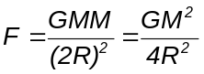 ; Ans: B

Example 3 (N09/I/16) Binary Stars
x
x
O
2M
M
Two stars of mass M and 2M, at a distance 3x apart, rotate in circles about their common centre of mass O.
The gravitational force acting on the stars can be written as 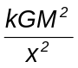.
What is the value of k?
A 0.22 B 0.50 C 0.67 D 2.0
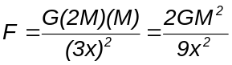 ⇒ k = 2/9 = 0.22
Ans: A

Example 4
A space capsule is travelling between the Earth and its Moon. Considering only the gravitational forces of the Earth and the Moon, find the distance from the Earth at which it is subjected to zero gravitational force. (Given: Mass of the Earth, M_{E} = 6.0 × 10²⁴ kg; mass of the Moon, M_{M} = 7.4 × 10²² kg; distance between the centres of the Earth and Moon, D = 3.8 × 10⁸ m)
x
Earth
Moon
3.8 × 10⁸ m

Let the required distance from Earth be x.
gravitational force exerted on = gravitational force exerted on
capsule by Earth (F_{CE}) capsule by Moon (F_{CM})
∴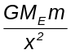 = 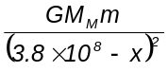
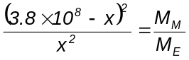
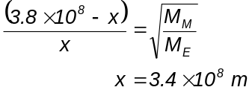
i.e. d² – (7.695 x 10⁸ + 1.462 x 10¹⁷ = 0
∴ d = 3.4 x 10⁸ m or 4.3 x 10⁸ m
Since the position where zero gravitational force exists is in between the Earth and the Moon, d = 3.4 x 10⁸ m.

LO (a)
7.3 Gravitational Field

Think about it: How can two objects exert attractive force on each other when they are not in contact with each other?

Every object sets up a gravitational field around itself due to its mass. When two objects enter each other’s gravitational fields, they will be attracted towards each other. Hence, a gravitational field (an example of force field) is a region of space in which any object lies in it experiences a gravitational force towards the object that creates the field, due to its mass. (For your information, magnetic fields and electric fields are also examples of force fields.)

Inquiry:
Gravitational field is invisible and is represented by imaginary field lines. How would the Earth’s gravitational field (both near and over large distances from Earth) looks like?
- Draw a few small masses (using pencil) placed near the Earth’s surface below and draw the direction of gravitational forces acting on them by Earth.
- The gravitational field near Earth’s surface is uniform
- The field lines should be drawn parallel to each other and of equal spacing.

Near Earth’s surface

2) Draw a few small masses (using pencil) placed far from the Earth below and draw the direction of gravitational forces acting on them by Earth.

- The gravitational field around Earth is non-uniform.
- The field lines should be drawn radially pointing towards the centre of Earth.

Earth

LO (e)
What can you infer from the spacing of these gravitational field lines?
- The closer the field lines, the stronger the gravitational field.
- Near Earth’s surface, the field strength is approximately constant (around 9.81 m s⁻²) and hence the gravitational field lines are almost equidistant from each other.
- Over large distances from Earth, the gravitational field strength decreases as it gets further from Earth and hence the gravitational field lines space out further from each other.

7.4 Gravitational Field Strength (symbol: g and units: N kg⁻¹ or m s⁻²)

As seen in section 7.3, the gravitational field strength acting on an object decreases (illustrated by an increase in the field line spacing) as the object moves further away from Earth. This means that field strength varies with distance from the source mass (in this case, the Earth).

The gravitational field strength, g at a particular point in free space is defined as the
gravitational force per unit mass acting on a point mass placed at that point.

Inquiry:
Why must it be a “point mass”?
Point mass is physically small so that the forces acting on different parts of the point mass are generally the same.

Based on Newton’s law of gravitation, the gravitational force acting on the point mass, m by the source mass, M, 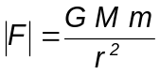; and gravitational field strength, g is the gravitational force, F per unit mass acting on the point mass, m, we may derive that the gravitational field strength,
LO (c)
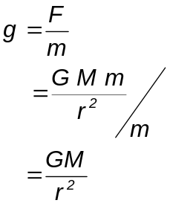

Note:
- Gravitational field strength, g is a vector quantity, and it is in the same direction as the gravitational force.
- The gravitational field strength of Earth is approximately constant at 9.81 N kg^{–1}, near its surface. It is also known as the acceleration of free fall or the acceleration due to gravity.
- As shown in the derivation above, the gravitational field strength, g of the source mass, M is independent of the mass of the point mass, m.
- As distance r of the point mass from source mass increases, g decreases in an inverse square law manner. Hence gravitational field is also known as an inverse square law field.
- Sketch the g vs r graph for a 500-kg mass below:
g
- Take the direction to the right as positive.
- On the left side of the 500-kg mass, the gravitational field strength points to the right (positive g values).
- On the right side of the 500-kg mass, the gravitational field strength points to the left (negative g values).
- As r increases, magnitude of g decreases.

r

- Complete section (A) & (B) in ICT inquiry worksheet 1 to build your conceptual understanding on gravitational field strength.

Example 5 (Application of gravitational field strength)
Considering the gravitational field strength on the surface of Earth as 9.81 N kg⁻¹, calculate the mean density of the Earth. State any assumptions you made in your calculation.
(Given: radius of the Earth = 6.37 x 10⁶ m; G = 6.67 x 10⁻¹¹ N m² kg⁻²)
LO (d)
Since g = 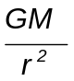
∴9.81 = 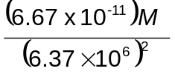
∴ M = 5.968 x 10²⁴ kg
Since V = 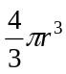= 1.083 x 10²¹ m³
Thus, density = 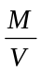= 5.51 x 10³ kg m⁻³
Assumption made: The Earth is spherical.

Assuming the Earth to be homogeneous (uniform density) and spherical.
r
g
Consider g = GM/r²
∴9.81 = (6.67 x 10⁻¹¹)M/(6.37 x 10⁶)²
∴ M = 5.968 x 10²⁴ kg
Since V = 4πr³/3 = 1.083 x 10²¹ m³
Thus, density = M/V = 5.51 x 10³ kg m⁻³

Example 6 (Application of gravitational field strength)
A space capsule is travelling between the Earth and the moon.
(a) Find the net gravitational field strength at the mid-point between the Earth and the moon.
(b) Hence find the net gravitational force acting on the space capsule at that point.
(Given: Mass of Earth, Moon and space capsule are 6.0 x 10²⁴ kg, 7.4 x 10²² kg and 100 kg respectively; distance between the centres of the Earth and Moon = 3.8 × 10⁸ m)

Earth
3.8 × 10⁸ m
Moon
g_{E}
g_{M}

(a) Net field strength, g_{net} = g_{E} – g_{M}
= 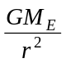– 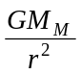
= (6.67 x 10⁻¹¹) (6.0 x 10²⁴ – 7.4 x 10²²)/(1.9 x 10⁸)²
= 1.09 x 10⁻² N kg⁻¹ (towards the centre of Earth)

(b) Net gravitational force = m g_{net}
= 100 (1.09 x 10⁻²)
= 1.09 N (towards the centre of Earth)

(a) Net field strength, g_{net} = g_{E} – g_{M} = GM_{E}/r² – GM_{M}/r²
= (6.67 x 10⁻¹¹)(6.0 x 10²⁴ – 7.4 x 10²²)/(1.9 x 10⁸)²
= 1.09 x 10⁻⁴ N kg⁻¹ (towards centre of Earth)

(b) Gravitational force = mg_{net}
= 100(1.09 x 10⁻⁴) = 1.09 x 10⁻² N (towards centre of Earth)

Inquiry:
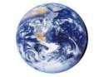An astronaut feels that he is ‘floating’ in a spacecraft in outer space as the spacecraft rotates around the Earth at a distance of 4 x 10⁷ m from the centre of Earth. He concludes that he is ‘floating’ because he is not experiencing any gravitational field of the Earth. Suggest whether his conclusion is right.
No, because even though the spacecraft is so far away from Earth, the g acting on it is still not zero. Based on the formula, g is 0.25 m s⁻² at that point of 4 x 10⁷ m away from Earth.

7.5 Gravitational Potential Energy (symbol: U and units: J)

In the previous topic 5 on Work, Energy & Power, we have dealt with the calculation of gravitational potential energy (GPE) using the formula, mgh. This formula was applicable in that topic because we were dealing with situations where the height (measured from a certain reference level decided by you) was relatively small (as compared to the radius of Earth) and hence the g of Earth was assumed to be constant (9.81 m s⁻²) over this height. In fact, if you think about it, mgh gives the ‘GPE’ of the object from a certain reference level (decided by you) and hence the ‘GPE’ changes when the reference level changes. It is not the actual gravitational potential energy possessed by the object with reference to Earth!

In the case when the object is moved through a large change in height (relative to the Earth’s radius), the assumption that g is constant cannot be valid. Hence, to find the gravitational potential energy, U of mass m placed at a distance r away from a source mass M that sets up the gravitational field, the formula used is
U = 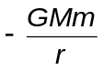
(towards centre of Earth)

.
U =
(towards centre of Earth)

To understand this formula:
- Gravitational potential energy is a scalar quantity (i.e. it has no direction and a negative value simply means it is less than zero).
- This expression implies that U is always negative (less than zero) and the larger the r, the smaller the value of 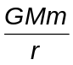 and hence the larger the value of U =. (For eg. – 2 is larger than – 4)
- When the object is moved to an infinitely far place where r = ∞, U becomes zero (which implies maximum gravitational potential energy, since zero is larger than any negative values).
- Note: by convention, infinity is taken as the reference level, which has zero gravitational potential energy. However it is the maximum U, instead of the minimum U!
Now, this leads to the definition of gravitational potential energy, U of mass m placed at a distance r away from a source mass M that sets up the gravitational field:
the work done in bringing the point mass from infinity to that point.

To understand this definition:
- Note that the work done to bring the mass m from infinity (somewhere infinitely far) to a particular point in space is carried out by an external force (not the gravitational force by source mass M).
- Since the mass m will be attracted towards the source mass M by its gravitational force, the external force acting on mass m will be pointing away from the source mass M, so that mass m can be placed/stopped at that particular point.
- Draw the external force F and displacement s in the diagram below.
Infinity
That point

M
s
r
m
F

Negative

- Is the work done positive or negative? Your answer: _________________
- Now think about your answer and link it to the formula U above.
- Explain why there is a negative sign in the expression U = .
The negative sign of the expression indicates that the work done by the external force is negative as it acts against the attractive nature of the gravitational force.

- Is the force F constant as the mass m is moved from infinity to that point?
No, because the gravitational force increases as m gets closer to M.

Example 7
The diagram shows two points X and Y at distances L and 2L, respectively, from the centre of the Earth (of mass M). Find an expression for the change in the gravitational potential energy of a mass m as it is brought from X to Y.
X
Y
M
L
2L

Change in GPE, ΔU = Final GPE – Initial GPE
= 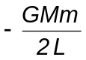– 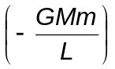
= 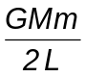
Note: The GPE increases as the object is brought away from the source mass (in this case, the Earth).

Change in GPE, ΔU = Final GPE – Initial GPE
= -GMm/2L – (-GMm/L)
= GMm/2L

LO (f)
7.6 Gravitational Potential (symbol: φ and units: J kg⁻¹)

The gravitational potential, φ, at a point due to the gravitational field set up by a mass M is defined as
the work done per unit mass in bringing a point mass from infinity to that point.

the work done in bringing a unit mass from infinity to that point.

Mathematically, it can be shown that
φ = 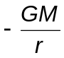

Note:
- This expression is similar to the expression for gravitational potential energy, U. The only difference from U is that φ is work done per unit mass.
- Gravitational potential is a scalar quantity. (i.e. it has no direction and a negative value simply means it is less than zero).
- This expression implies that φ is also always negative (less than zero) and by convention, the gravitational potential at infinity is also taken to be zero (maximum).
- Similar to gravitational field strength, gravitational potential is also independent of the mass of the point mass, m.
- As distance r of the point mass from source mass increases, φ increases.

- Sketch the φ vs r graph for a 500-kg mass below:
φ
r

- On either sides of the 500-kg mass, the gravitational potential is always negative.
- As r increases, φ increases (becomes less negative).

- Complete section (C) & (D) in ICT inquiry worksheet 1 to build your conceptual understanding on gravitational potential.
LO (g)
Example 8 (Application of gravitational field strength and potential)
Three identical point masses A, B and C, each of mass 2.0 x 10⁵ kg form the vertices of an equilateral triangle with a side length of 1000 m. What is the net gravitational field strength and gravitational potential at point X which is located at the midpoint of AC?
A
C
B
g_{A}
g_{B}
g_{C}

X

AX = CX = 1000 / 2 = 500 m
BX = 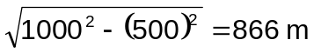

Since g_{A} will cancel out g_{C}, net g at X = g_{B}
= 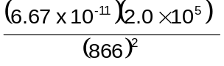
= 1.78 x 10⁻¹¹ N kg⁻¹ (towards B)

Net gravitational potential at X, φ_{X} = φ_{XA} + φ_{XB} + φ_{XC}
=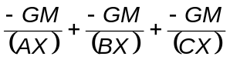 =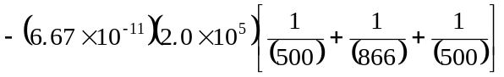
= - 6.9 x 10⁻⁸ J kg⁻¹
AX = CX = d/2
BX = 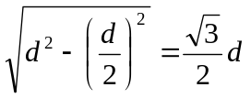
Thus, total gravitational potential at X, φ_{X} = φ_{XA} + φ_{XB} + φ_{XC}
= 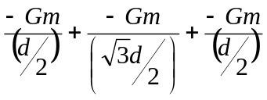
=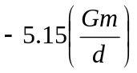

Compare & contrast among the four main quantities in Gravitation:

Vector quantities |  |  |  | Scalar quantities
Force, | | F | = | 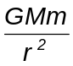 | [N] | Potential energy, | U = |  | [J]
F  r  Pointing in the positive direction  Pointing in the negative direction |  |  |  | U  r  All values are less than zero
Vector quantities |  |  |  | Scalar quantities
Field strength:  Force per unit mass | | g | = |  | [N kg⁻¹]  or  [m s⁻²] | Potential:  Potential energy per unit mass | φ = |  | [J kg⁻¹]
r  g  Pointing in the positive direction  Pointing in the negative direction |  |  |  | φ  r  All values are less than zero

7.7 Relationship between F and U; between g and φ

To understand how F is related to U:
- Compare F and U in the above table.
- If we differentiate U = with respect to r, we will get the gradient of the U vs r graph, 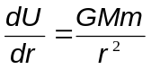. This is the same expression as F.
- However if we observe the two graphs carefully, on the side where r is positive, the gradient of U vs r graph is positive but the value of F is negative. And on the side where r is negative, the gradient of U vs r graph is negative but the value of F is positive.
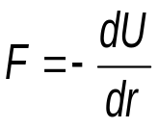
- Hence it can be concluded mathematically that

- Recap what you have learnt in section 5.3.5 in the topic of Work Energy Power.

To understand how g is related to φ:
- Similarly, compare g and φ in the above table.
- If we differentiate φ = 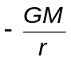 with respect to r, we will get 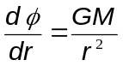, which has the same expression as g.
- Again if we observe the two graphs carefully, on the side where r is positive, the gradient of φ vs r graph is positive but the value of g is negative. And on the side where r is negative, the gradient of φ vs r graph is negative but the value of g is positive.
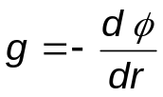
- Hence, mathematically,

- Complete section (E) in ICT inquiry worksheet 1 to build your conceptual understanding on the relationship between gravitational field strength and potential.

Example 9 (J89/II/2)
Values for the gravitational potential due to the Earth are given in the table below.

Distance from Earth’s surface / m | Gravitational potential / MJ kg⁻¹
0  390 000  400 000  410 000  Infinity | -62.72  -59.12  -59.03  -58.94  0

- If a satellite of mass 700 kg falls from a height of 400 000 m to the Earth’s surface, how much potential energy does it lose?
- Deduce the magnitude for the Earth’s gravitational field strength at a height of 400 000 m.

- ΔGPE = (m) (φ_{f} - φ_{i}) = (700) [(-62.72) - (-59.03)] 10⁶) = - 2.58 x 10⁹ J
Hence the loss in GPE = 2.58 x 10⁹ J

- Since 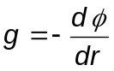,
Consider 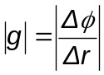 for 390 000 m ≤ r ≤ 410 000 m
i.e. 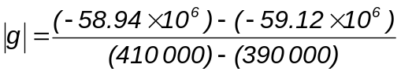= 9.0 N kg⁻¹

- Loss of GPE = m x Δφ = 700[(-59.03)-(-62.72)](10⁶) = 2.58 x 10⁹ J

- Since 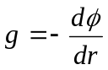,
Consider 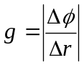 for 390 000 m ≤ r ≤ 410 000 m
i.e. 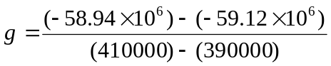= 9.0 N kg⁻¹
7.8 Satellite in Circular Orbits

Earth
LO (i)
An object projected horizontally near the Earth’s surface follows a parabolic trajectory as shown on the right. As the speed of projection increases, the object will reach a speed where the trajectory follows the curvature of the Earth’s surface. If air resistance is negligible, the object will orbit round the Earth continuously and will never meet the Earth’s surface.

Many man-made satellites move in circular orbits around the Earth. The first man-made satellite, the “Sputnik 1”, was launched by Soviet Union in 1957. Since then, hundreds of satellites have been launched into orbit around the Earth. The only force acting on the satellite in a circular orbit is the Earth’s gravitational force. The gravitational force is directed towards the centre of Earth (which is also the centre of the circular orbit).

Since the satellite moves perpendicular to the gravitational force, its magnitude of velocity remains constant while its direction changes. This means that the satellite is travelling in a uniform circular motion (recap Topic 6). At the same time, the distance from the satellite to the centre of Earth will also remain constant in this circular orbit.

For a satellite (or any object) in circular orbit, the gravitational force acting on it is the centripetal force that keeps it in circular motion.
M
m
v
r
Satellite’s Orbit
Earth

Hence, ΣF = 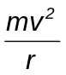
F_{G} =
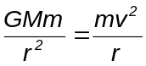
i.e. 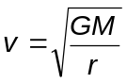

where v denotes the orbiting speed of satellite.

The above formula can be used to calculate the speed required for any object to orbit around a planet of mass M at a constant distance r.

Inquiry:
What will happen to the orbiting satellite if it starts to slow down?
The gravitational force will be higher than the required centripetal force to keep it in the uniform circular motion. Hence the satellite will be pulled closer towards Earth and move in a smaller circular orbit.

Example 10 (Object in orbit)
How fast must the satellite be moving in its circular orbit about the Earth, if it stays at a constant height of three times of Earth’s radius, above the Earth’s surface?
(Given: mass of Earth = 6.0 x 10²⁴ kg; radius of Earth = 6.4 x 10⁶ m)
M
m
v
r
Earth
h
r = 4 x radius of Earth = 2.56 x 10⁷ m
ΣF =
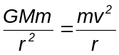

thus orbiting speed of satellite,

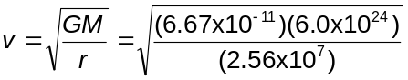

i.e. v = 3954 = 4.0 km s⁻¹

7.9 Kepler’s Third Law

Earlier, it was stated that the gravitational force acting on a satellite in orbit is the centripetal force to keep it in circular motion.

i.e. ΣF = mrω²
F_{G} = mrω²
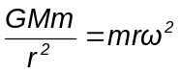
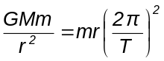
Hence, 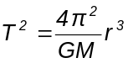

or 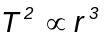

This is the Kepler’s Third Law, which states that the square of the period of an object in circular orbit (i.e. the gravitational force acts as the centripetal force) is directly proportional to the cube of the radius of its orbit.

Note:
- The Kepler’s Third Law is only applicable to masses in circular orbit, whereby the gravitational force is the only force acting on it to act as its centripetal force.
- Complete ICT inquiry worksheet 2 to build your conceptual understanding on the Kepler’s Third Law.
7.10 Geostationary Satellites
LO (j)
A geostationary (Earth) satellite is a satellite that rotates around Earth in a certain orbit such that it is always positioned above the same point on the Earth’s surface. Hence from the point of view of an observer standing at that point, the geostationary satellite appears to be always ‘stationary’ above him/her (but actually, both observer and satellite are rotating at the same angular speed). In order for a satellite to be moving in such a geostationary orbit, there are certain conditions to meet:

- Geostationary satellites must be placed vertically above the equator (so that its axis of rotation is the same as the Earth’s);
- They must move from west to east (so that it moves in the same direction as the rotation of the Earth about its own axis);
- The satellite’s orbital period must be equal to 24 hrs (so that it is the same as the Earth’s rotational period about its own axis).

Inquiry:
Complete ICT inquiry worksheet 3 to build your conceptual understanding on the Geostationary satellite.
Equator
Axis of rotation

Then draw to illustrate how a geostationary satellite orbits around the Earth on the right.

All geostationary satellites must be placed in an orbit at a fixed distance (around 35 700 km) from the Earth’s surface, in order to rotate with the same period as Earth. Do you know why? (Hint: recall Keper’s Third Law)

Advantages of geostationary satellites:

1. A geostationary satellite is ideal for telecommunication purposes since it remains ‘stationary’ above the same spot on the Earth’s surface at all times. The distance between the satellite and the transmitting station on Earth is kept relatively constant and a clear line of ‘vision’ between the transmitter and the receiver allows continuous and uninterrupted signal transmission.
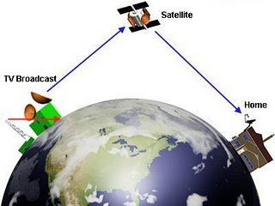

2. Since it is always at the same relative position above the Earth’s surface, there is no need to keep adjusting the direction of the satellite dish to receive signals from the geostationary satellite.
3. As geostationary satellites are positioned at a high altitude (a distance of 3.57 × 10⁷ m away from the surface of the Earth), it can view a large section of the Earth and scan the same area frequently. Hence, they are ideal for meteorological applications and remote imaging.
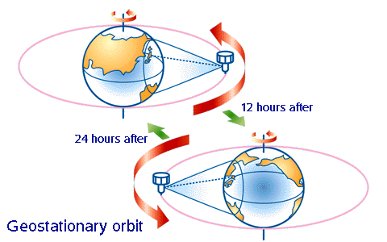

Disadvantages of geostationary satellites:

1. As geostationary satellites are positioned at such a high altitude, the resolution of the images may not be as good as those captured by the lower orbiting satellites.

2. Because of its high altitude, there may be a delay in the reception of the signals resulting in a lag time for live international broadcast or video conferencing.

3. The transmitting stations in countries positioned at latitudes higher than 60 degrees may not be able to receive strong signals from geostationary satellites, as the signals would have to pass through a large amount of atmosphere. This is true for countries beyond the 60 degrees latitude ‘belt’, both on north and south sides.

Besides geostationary satellites which are placed at a large distance from Earth, there are other types of satellite which orbit at lower altitudes from Earth, like the polar orbit satellites as shown below.

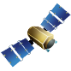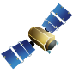
Equator
Northern Hemisphere
Southern Hemisphere
Geostationary orbit
(about 36,000 km above Earth’s surface)
Mainly for telecommunication
Polar Orbit or Low Earth Orbit
(600-2000 km above Earth’s Surface)
Mainly for navigation (GPS), weather forecast and closer up aerial view of the Earth. A string of 12 satellites lie in a polar orbit.

Asynchronous
orbit
Polar orbit

Satellites in polar orbits rotate around the Earth over the poles, in a constant plane perpendicular to the equator. Polar satellites have much lower altitudes (about 850km) which serve to provide more detailed information about the weather and cloud formation. However satellites in this type of orbit can view only a narrow strip of Earth's surface on each orbit. Strips of images must be "stitched together," to produce a larger view.

Advantages of low altitude orbit satellites (eg. polar orbit):

1. Due to their lower altitudes, these satellites can capture images of the Earth’s surface with higher resolution. Polar satellites have the advantage of photographing close up images of Earth.

2. There is reduced lag time or delay between the transmission and reception of the signal.

Disadvantages of low altitude orbit satellites (eg. polar orbit):

1. It is not possible to view the same spot on the Earth's surface continuously by a single satellite in a polar orbit. A typical low orbit satellite would take about 2 hours to make one revolution round the Earth. In order to have a continuous relay of data, there must be a series or chain of satellites in the same orbit so that one ‘takes over’ the predecessor’s function.

2. Because the satellite changes its location constantly with respect to the Earth’s surface, the direction of the satellite dish would need to be adjusted constantly as well.

Example 11
Determine the typical orbital radius of a geostationary satellite around Earth.
(Given: mass of Earth = 6.0 x 10²⁴ kg)

The orbital period for geostationary satellite = period of rotation of Earth = 24 hours
Thus, T = 24 hr x 60 min x 60 sec = 8.64 x 10⁴ s
Using ΣF = 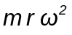
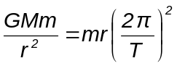
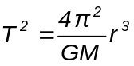
∴ 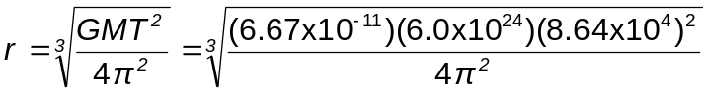

i.e. r = 4.2 x 10⁷ m (about 6.6 times of Earth’s radius)

The orbital period for geostationary satellite = period of rotation of Earth = 1 day
Thus, T = 1 day x 24 hr x 60 min x 60 sec = 8.64 x 10⁴ s
Using 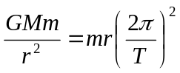, 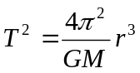
∴ 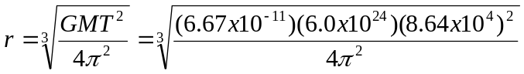
i.e. r = 4.2 x 10⁷ m (about 6.6 times of Earth’s radius)

Inquiry:
Would a geostationary satellite that orbit around planet Mars be at the same distance r (= 4.2 x 10⁷ m), as Example 11? Why?
No, because the period of rotation and mass of planet Mars are not the same as Earth’s.

Example 12 (J2000/1/8)
Which quantity is not necessarily the same for satellites that are in geostationary orbits around the Earth?

A angular velocity C kinetic energy
B centripetal acceleration D orbital period
Kinetic energy is dependent on the satellite's mass and velocity. Hence different satellites of different masses may have different kinetic energies. Ans: C

Example 13
A spacecraft was launched from Earth into a circular orbit around Earth that was maintained at an almost constant height of 189 km from the Earth's surface. Assuming the gravitational field strength in this orbit is 9.4 N kg⁻¹, and the radius of the Earth is 6 370 km.
a) Calculate the speed of the spacecraft in this orbit.
b) Find the time to complete one orbit.
c) Comment whether this spacecraft is in a geostationary orbit.

- Since ΣF =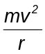, F_{G} =
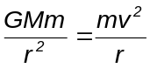
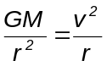
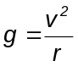
∴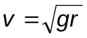
= [(9.4) (6370 + 189) (10³)]^{0.5}
= 7852
= 7.85 x 10³ m s⁻¹

(b) T = 2πr/v = 2π(6559 x 10³) / 7852
= 5249 s
= 87.5 min

(c) Spacecraft is not in geostationary orbit as the period of rotation is less than period of Earth’s rotation about its own axis (24 hr).
(a) Since F_{G} = F_{C}
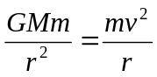
i.e. 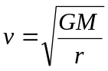
As g = GM/r²
∴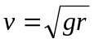 = [(9.4)(6370 + 189)(10³)]^{0.5}
= 7852 = 7.85 x 10³ m s⁻¹

(b) T = 2πr/v = 2π(6559 x 10³)/7852 = 5249 s = 87.5 mins

7.11 Energy of a Satellite in orbit

A satellite in orbit possesses both kinetic energy, E_{K}, (by virtue of its motion) and gravitational potential energy, E_{P}, (by virtue of its position within the Earth’s gravitational field).

Hence, total energy of a satellite, E_{T} = E_{P} + E_{K}
=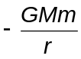+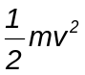 --- Equation (1)

Recall that for a satellite in orbit, its gravitational force acts as the centripetal force:
ΣF = → 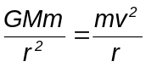

i.e. E_{K} = 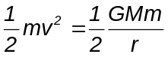 --- Equation (2)

Substituting equation (2) into (1),
Hence total energy of a satellite, E_{T} = E_{P} + E_{K}
E_{T} =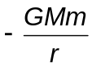+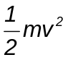

E_{T} =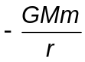+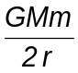

E_{T} = 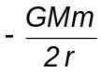 [Note: E_{T} = − E_{K} or ½ E_{P}]

A typical graph showing the relationship between E_{T}, E_{P} and E_{K} with respect to the distance, r, from centre of Earth, O, is as shown. Label the graphs accordingly.
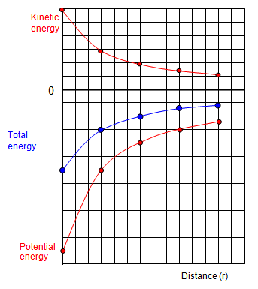
E_{T}/J, E_{P} /J, E_{K} /J
E_{K}
E_{T}

Earth
Distance, r

E_{P}
Example 14

An Earth satellite of mass 200 kg lost energy slowly through atmospheric resistance and fell from an orbit of radius 8.0 x 10⁶ m to 7.8 x 10⁶ m. Calculate the changes in the potential, kinetic and total energies of the satellite as a result of this transition. (Mass of Earth = 6.0 x 10²⁴ kg)
Consider ΣF =,
F_{G} = 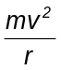
i.e. 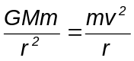
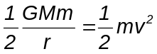

Thus, change in kinetic energy, ΔE_{K}
= 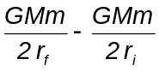
= 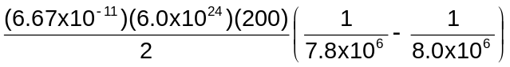
= 1.28 x 10⁸ J (increase)

Since E_{P} = -2 E_{K} ,
∴ ΔE_{P} = -2 ΔE_{K}
Thus, change in potential energy, ΔE_{P} = - 2 (1.28 x 10⁸)
= - 2.57 x 10⁸ J (decrease)

Since E = E_{P}
∴ ΔE = Δ E_{P}
= - 1.28 x 10⁸ J (decrease)

Appendix A – Example of Application of 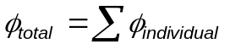

Revision: The total φ at a point in a field due to two or more source masses is the scalar addition of the individual φ due to each mass at that point, i.e. . The same principle applies when determining U_{total}.

Showing how the gravitational potential varies between the surface of the Moon and the surface of the Earth along the line joining the centres.

Earth
Moonoon
+
-
Gravitational potential due to Earth
Gravitational potential due to Moon
Net gravitational potential along the line of centres is equal to the sum of the gravitational potentials due to the Earth and Moon.

Appendix B – Escape Speed

Is it true that “what goes up must come down”?
It is only accurate to say that “what goes up may come down”. There is a critical speed at which an object can be launched such that it can escape the Earth permanently. Such a critical speed is termed as the escape speed.

Example

Determine an expression for the escape speed, v, of a rocket of mass m launched from the surface of Earth of mass M and radius R.

To escape from Earth, it implies that the rocket must be brought from the surface of the Earth to infinity where GPE is zero.

Thus, initial KE of rocket must be larger than the change in GPE from Earth surface to infinity.
i.e. ½mv² ≥ [0 – (–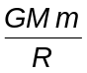)]
∴ ½mv² ≥ 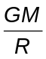
∴ 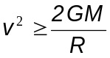
Hence, 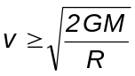
i.e. the escape speed is 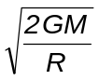.

More food for thought:
Do you know why the moon has no atmosphere?
Because the average speed of the air particles are higher than their escape speeds and hence they can escape from the moon surface.

If the Sun collapses inwards so that its density increases tremendously, the escape speed will be so large that even light (speed of light = 3.00 x 10⁸ m s⁻¹) cannot escape from it. The Sun would be invisible. It would become a black hole!

After sitting through the whole topic on gravitation, can you offer a good explanation as to why many planets are almost spherical?

